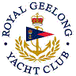 | Royal Geelong Yacht Club Inc.  Est 1859
Trophy Deed of Gift.

Trophy: | Women’s Dinghy Series Trophy
Presented by: | Ray Goodwin
Date: | 2014
For: | Women’s Pacer Championship Series
Remarks / Revisions
Click HERE for a list of the Recipients

